Name_______________________

Higher History
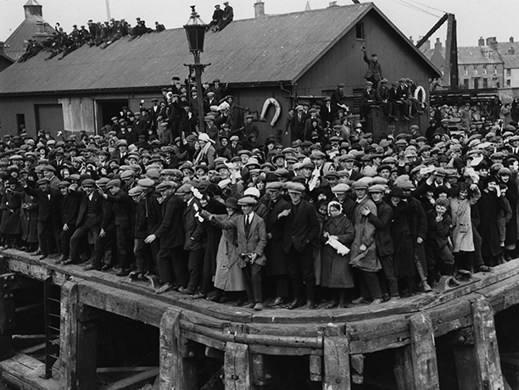

Migration and Empire
1830-1939
Booklet 1
Section 1 – Migration and Emigration
Source 1
Migration is the movement of people within a country. Normally it is associated with the shift of people from the countryside to the towns, but it can also be a useful term to describe the movement of population from a depressed economic region to an active one.
Emigration is the movement of people from one country to another. It is the result of push and pull effects. The push comes from poor economic conditions or political oppression at home; the pull effect is generated by the attracting powers of the other country, including the promise of higher wages, political freedom and economic opportunity.
Migration within Scotland during the 19th and early 20th century can be divided into two different categories; Lowland and Highland Migration. Despite some similarities between the two areas, the systems of land holding, farming and employment remained significantly different - which in turn meant that those living in rural communities were affected differently by the changes that occurred during this time.
Task 1 – In your own words, explain the difference between migration and emigration.
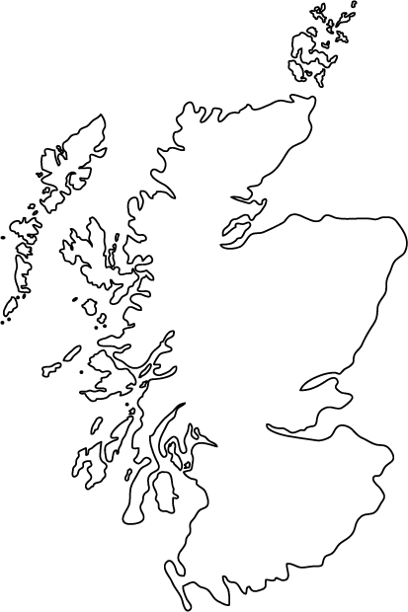
_________________________________________________________________________________________________________________________________________________________________________________________________________________________________________________________________________________________________________________________________________________________
Task 2 – Mark the following features on your map;

Highlands
Lowlands
Edinburgh
Aberdeen
Glasgow
Lewis
Skye
Dundee

Source 2
The ability of agriculture to feed more people and the capability of industry to absorb the surplus population in work saw the population of the country nearly double from 1.625m in 1801 to 2.896m in 1851. The most rapidly growing areas of population were the industrial cities. Glasgow's population mushroomed from 77,000 in 1801 to 275,000 forty years later. Dundee saw its population in the same period grow spectacularly from 26,000 to 166,000. Equally affected were the smaller industrial towns like Paisley, which witnessed a dramatic increase in population from 4,000 in the 1750s to 24,000 in 1800, before nearly doubling again to 47,000 in 1821.
At the same time, there was a drop in the population of the Highlands. People left rural, inland areas such as Kildonan and settled on the coast instead. Many moved to the central belt.
Task 3 – What does Source 2 tell us about what was happening to the Scottish population?
________________________________________________________________________________________________________________________________________________________________________________________________________________________________________________________________________________________________________________________________________________________________________________________________________________________________________________________________________________________________________________________________________________________________________
Task 4 – Write down what you already know about the Highland Clearances.
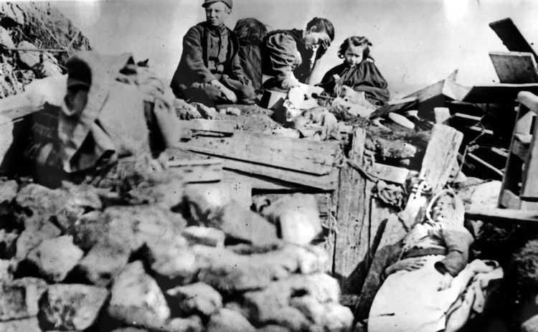
Prior Knowledge

Source 3 – Education Scotland
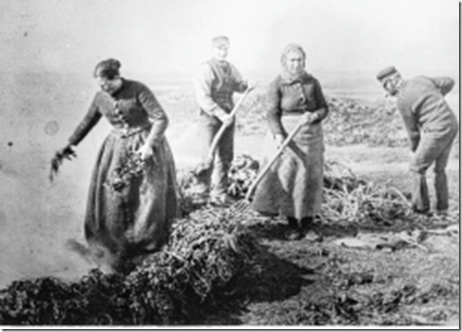
Throughout the 18th and 19th centuries, seaweed was gathered for use as a fertiliser on croft lands and rigs. It was also used more and more, and in huge quantities, in various chemical processes, such as soap and glass making. For this purpose it had to be dried out and carefully burned in a kelp pit, trench or kiln. The resulting kelp was shipped away to factories in the Lowlands.
Kelp was a crucial livelihood, especially in the Outer Hebrides, but after 1822 the duty payable on cheaper, imported kelp was removed, and the Scottish industry largely collapsed. This brought hardship in places like Lewis, Benbecula and South Uist, already reeling from the Clearances.
Source 4 -
As in Ireland, there was a potato famine in Scotland in the mid-19th century (1846 - 1857). Although the potato famine in the Highlands did not have such a devastating effect as it had in Ireland (mainly due to the fact that Highlanders did not rely solely on the potato for food), it did cause starvation (especially amongst the old and the young). This paved the way for another wave of forced migration. Moreover, a widespread Cholera outbreak further weakened the Highland population.
The weather has also been blamed - a succession of bad harvests and famine demanded a drastic solution. Crop failure following atrocious weather conditions in 1926, for example produced a major social crisis. The government were forced to intervene with emergency food supplies in Lewis and elsewhere. Many were forced to migrate.
Rising population, putting pressure on land and jobs, also played a part. In the south and east Highlands there was a fall in the number of tenancies, which created a large pool of landless labourers dependent on wages.
Poor housing was another reason for depopulation. Although the buildings were substantial, the walls were made of clay and wattle, or of thickly cut turf and the roofs were thatched in heather, broom, or bracken. They were often badly built and lacking in basic essentials. In such houses dampness, cold and smoke dust were constant problems.
As a result of foreign competition the fishing industry went into decline. The income of most families in the Hebrides (and many in the rest of the highlands) was dependent upon earnings from seasonal fishing. Prices of herring fell between 1884 and 1886 as a result of record catches and higher European import duties. As a result, wages also went into decline. The average earnings of a Hebridean seasonal worker fell dramatically from £20 - £30 (per season) in the early 1880s to only £1 - £2 a decade later. The Russian Revolution saw an end to the massive export trade in herring to eastern Europe.
Task 5 – Complete the table below to show why many people left the Highlands between 1830 and 1930. Each factor should have specific evidence to support it.
Factor | Details
Growth in Sheep Farming

Potato Blight

Sub-Division of Land

Decline in Kelp

Other factors

Source 5
The traditional image of 19th Century migration from the Highlands of Scotland is that of the Highland Clearances. Although this was clearly a hugely significant reason for migration, the eviction of Highlanders from their homes reached a peak in the 1840s and early 1850s. After 1855, mass evictions were rare and migration became more a matter of choice rather than compulsion. In the years between 1855 and 1895 the drop in population of the Highlands was actually less than it was in the Lowlands - and certainly much lower than it was in Ireland. The Highlands experienced a 9 per cent fall in population between 1851 and 1891, while Ireland in the same period faced a 28 per cent fall. The Crofters Holding Act of 1886 also gave the crofters more security of tenure and this helped to slowed down the process of migration. In 1831 the population of the Highlands reached a peak of 200,955, or 8.5 per cent of the total population of Scotland. In 1931 the comparable figures were 127,081 or 2.6 per cent!"
Task 6 –
Find two pieces of evidence in the source which show that many people left the Highlands between 1830 and 1930.
____________________________________________________________________________________________________________________________________________________________________________________________________________________________________________________________________________________
Find two pieces of evidence in the source that show that the Highland Clearances were not the main cause of migration between 1830 and 1930.
____________________________________________________________________________________________________________________________________________________________________________________________________________________________________________________________________________________
Read Extension Article 1 and summarise the main arguments that Professor Devine makes.
Task 7 – Annotate the lyrics to show how the song relates to the Highland Clearances.
Hush, hush, time to be sleeping
Hush, hush, dreams come a-creeping
Dreams of peace and of freedom
So smile in your sleep, bonny baby
Once our valleys were ringing
With songs of our children singing
But now sheep bleat till the evening
And shielings lie empty and broken
Where is our proud highland mettle
Our troops once so fierce in battle
Now stand, cowed, huddled like cattle
And wait to be shipped o'er the ocean
No use pleading or praying
For gone, gone is all hope of staying
Hush, hush, the anchor's a-weighing
Don't cry in your sleep, bonny baby

Task 8 – Explain why many people were forced to leave the countryside in the Lowlands.
__________________________________________________________________________________________________________________________________________________________________________________________________________________________________________________________________________________________________________________________________________________________________________________________________________________________________________________________________________________________________________________________________________________________________________________________________________________________________________________________________________________________________________________
Source 6 -
The cities and towns provided a more stable life for different reasons. One of the major reasons was the higher wages to be earned in urban areas. On moving to a town a former agricultural labourer might earn 50% more in industrial work, although he was less well protected from the impact of economic depression.
Of equal importance in moving to the towns was the prospect of a more varied social life and an end to the isolation of living on the land. As the 20th century dawned, this included dances, visits to the cinema or theatre, and sporting events like football, rugby or horse racing.

Task 9 – Complete the spider diagram to show the different pull factors which encouraged Scots to move to cities such as Edinburgh and Glasgow.

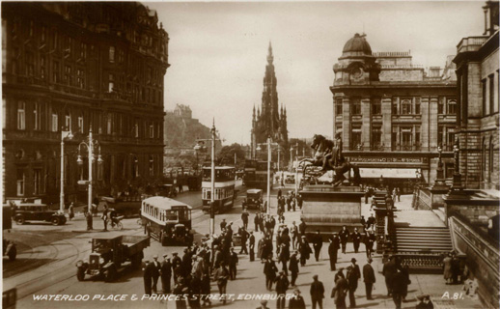

Task 10 – Why did the growth of the rail network contribute to migration within Scotland?

____________________________________________________________________________________________________________________________________________________________________________________________________________________________________________________________________________________
Task 11 –
Source A
The eviction of Highlanders from their homes reached a peak in the 1840s and early 1850s. The decision by landlords to take this course of action was based on the fact that the Highland economy had collapsed, while at the same time the population was still rising. As income from kelp production and black cattle dried up, the landlords saw sheep as a more profitable alternative. The introduction of sheep meant the removal of people. The crofting population was already relying on a potato diet and when the crop failed in the late 1830s and again in the late 1840s, migration seemed the only alternative to mass starvation.

How fully does Source A explain the reasons for Scottish migration between 1830 and 1930? 9
______________________________________________________________________________________________________________________________________________________________________________________________________________________________________________________________________________________________________________________________________________________________________________________________________________________________________________________________________________________________________________________________________________________________________________________________________________________________________________________________________________________________________________________________________________________________________________________________________________________________________________________________________________________________________________________________________________________________________________________________________________________________________________________________________________________________________________________________________________________________________________________________________________________________________________________________________________________________________________________________________________________________________________________________________________________________________________________________________________________________________________________________________________________________________________________________________________________________________________________________________________________________________________________________________________________________________________________________________________________________________________________________________________________________________________________________________________________________________________________________________________________________________________________________________________________________________________________________________________________________________________________________________________________________________________________________________________________________________________________________________________________________________________________________________________________________________________________________________________________________________________________________________________________________________________________________________________________________________________________________________________________________________________________________________________________________________________________________________________________________________________________________________________________________________________________________________________________________________________________________________________________________________________________________________________________________________________________________________________________________________________________________________________________________________________________________________________________________________
Task 12 – Complete the boxes below to explain why so many Scots emigrated between 1830 and 1930.

Opportunities Abroad
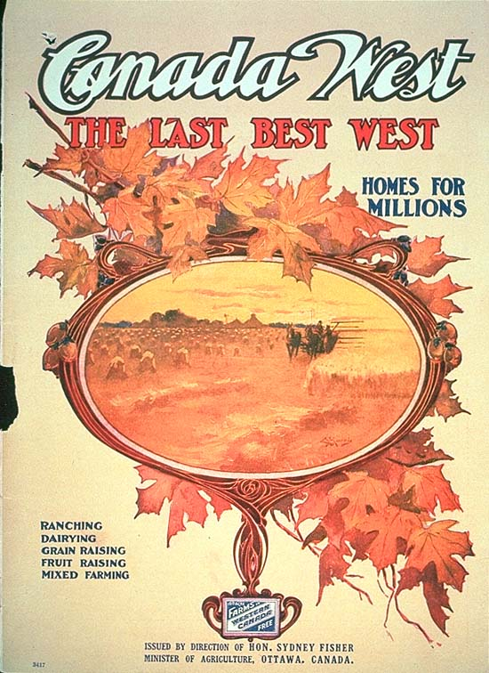

Problems in Scottish Towns
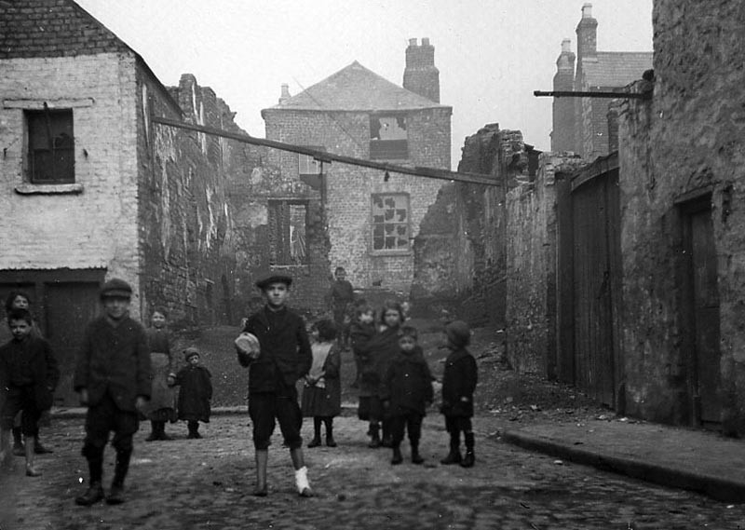

Financial Help Transport

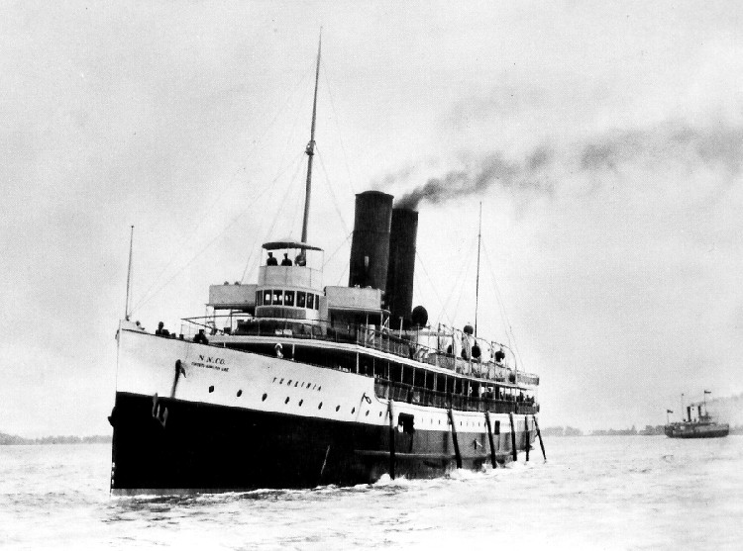

Encouragement

Task 13 –
Source B
Incessant rain had made it impossible for the population of the west coast to harvest the peat on which they depended for domestic fuel. In this extremity the poor people were, in some places, forced to burn their huts and cottages. They met and drew lots to decide which house was to be destroyed and afterwards in the same manner they decided which of their number was to maintain the poor family deprived of their home. In such situations, the crofts to which the mass of Highlanders had been driven as a result of earlier clearances had long since proved incapable of providing adequately for their occupants. Crofting families survived on a diet consisting largely of potatoes. When that crop failed, as it did regularly, hunger became a severe problem. Landlords, practically none of whom now felt any responsibility for the Highlander’s fate, simply organised more evictions in order to create still more sheep farms. People thus deprived of their crofts had little alternative but to go elsewhere. Hundreds, even thousands, of evicted families consequently left each year for Canada.

How far does Source A explain the reasons why many Scots emigrated? 9
__________________________________________________________________________________________________________________________________________________________________________________________________________________________________________________________________________________________________________________________________________________________________________________________________________________________________________________________________________________________________________________________________________________________________________________________________________________________________________________________________________________________________________________________________________________________________________________________________________________________________________________________________________________________________________________________________________________________________________________________________________________________________________________________________________________________________________________________________________________________________________________________________________________________________________________________________________________________________________________________________________________________________________________________________________________________________________________________________________________________________________________________________________________________________________________________________________________________________________________________________________________________________________________________________________________________________________________________________________________________________________________________________________________________________________________________________________________________________________________________________________________________________________________________________________________________________________________________________________________________________________________________________________________________________________________________________________________________________________________________________________________________________________________________________________________________________________________________________________________________________________________________________________________________________________________________________________________________________________________________________________________________________________________________________________________________________________________________________________________________________________________________________________________________________________________________________________________________________________________________________________________
Source C is an extract from the Glasgow Herald, 9th January 1852.
Vancouver Island is especially attractive to people planning to emigrate. The climate is similar to that of England, but it is milder. The soil is very good for growing wheat and other crops. Potatoes do especially well. Animals are easily reared and thrive well. The Hudson Bay Company is ready to grant land to anyone from Great Britain or Ireland who wants to settle there. The next ship for Vancouver Island sails in May 1852.
Task 14 - Evaluate the usefulness of Source C as evidence of the reasons for Scottish emigration. 6
Origin and Purpose _______________________________________________________________________________________________________________________________________________________________________________________________________________________________________________________________________________________________________________________________________________________________________________________________________________________________________________________________________________________________________________________________________________________________________________________________________________________________________________________________________________________________________________________________________________________________________________________
Source
__________________________________________________________________________________________________________________________________________________________________________________________________________________________________________________________________________________________________________________________________________________________________________________________________________________________________________________________________________________________________________________________________________________________________________________________________________________________________________________________________________________________________________________
Recall
__________________________________________________________________________________________________________________________________________________________________________________________________________________________________________________________________________________________________________________________________________________________________________________________________________________________________________________________________________________________________________________________________________________________________________________________________________________________________________________________________________________________________________________
Task 15 – Try to name each song and explain its connection to emigration.
Song | Connection to Emigration
Source D is from an article about emigration written by the editor of Chambers’ Journal, a popular weekly Scottish magazine, from 1872.
Canada continues to be a popular destination for Scots emigrants. Many Scots from the Highlands to the Lowlands have already taken up the opportunity of living abroad in places such as Ontario and Nova Scotia. Experienced farmers and skilled agricultural workers can earn far more overseas than they can here at home. The attraction of emigration to Canada is not simply this, but the familiarity and neighbourliness of living among fellow Scots who had already emigrated in the past. By far the biggest attraction is the confident prospect that the poorest may become landowners thereby earning sufficient to make a living and to comfortably settle one’s children.
Task 16 - Evaluate the usefulness of Source D as evidence of the reasons for Scottish emigration. 6
Origin and Purpose _____________________________________________________________________________________________________________________________________________________________________________________________________________________________________________________________________________________________________________________________________________________________________________________________________________________________________________________________________________________________________________________________________________________________________________________________________________________________________________
Source
_____________________________________________________________________________________________________________________________________________________________________________________________________________________________________________________________________________________________________________________________________________________________________________________________________________________________________________________________________________________________________________________________________________________________________________________________________________________________________________
Recall
__________________________________________________________________________________________________________________________________________________________________________________________________________________________________________________________________________________________________________________________________________________________________________________________________________________________________________________________________________________________________________________________________________________________________________________________________________________________________________________________________________________________________________________
Source E: from the Quarterly Journal of Agriculture 1832–1834.

I have not the slightest hesitation in declaring, that it appears to me as plain as the sun at noonday, that a farmer in Scotland, occupying a farm that does not pay him, distressed as he must be, struggling from morning to night with mental anxiety and worry pressing upon his mind and yet after all quite unable to support his family or better their circumstances—I say that a farmer continuing to remain in Scotland even when unemployed while so much land lies in Canada to occupy, acts the part of an insane person. In a short time there will be no cheap land to be procured about these parts. The best way for my brothers to lay out their money here in Canada is in buying land which is every year rising in value.

Source F: from the Scotsman, 20 February 1923, “Emigration boom in the Hebrides”.

Great interest is being taken in the scheme of the Ontario government to emigrate young men and women between 18 and 23 to Canada. The Ontario agent finds that he could treble the number he is authorised to enlist owing no doubt to the depressed state of trade in Lewis, the lack of employment generally and the inability of the farmers to satisfy the hunger of the families. Immediately on landing, employment will be found for farmers and the women can find employment in domestic work. The pay is good as experienced men can at the very start earn £5 to £6 per month. The men also have the prospect of becoming owners of their own farms once again.

Task 17 - To what extent do Sources E and F agree about the reasons for Scottish migration to Canada? 5

Top Tip – Use 4 different colours of highlighter. Use a different colour for each point of comparison contained in the source.

Specific Comparison 1

______________________________________________________________________________________________________________________________________________________________________________________________________________________________________________________________________________________________________________________________________________________________________________________________________________________________
Specific Comparison 2

______________________________________________________________________________________________________________________________________________________________________________________________________________________________________________________________________________________________________________________________________________________________________________________________________________________________
Specific Comparison 3

______________________________________________________________________________________________________________________________________________________________________________________________________________________________________________________________________________________________________________________________________________________________________________________________________________________________
Specific Comparison 4

______________________________________________________________________________________________________________________________________________________________________________________________________________________________________________________________________________________________________________________________________________________________________________________________________________________________
Overall Comparison
_______________________________________________________________________________________________________________________________________________________________________________________________________________________________________________________________________________________________________________________________________________________________________________________________________________________________________________________________________________________________________________________________________________________________________________________________________________________________________________________________________________________________________________________________________________________________________________________

Extension Article 1, Professor Tom Devine, University of Edinburgh

A number of years ago a sample of fourth year pupils in Scotland studying history were asked why were there such great emigrations from this country, and nearly sixty per cent of them responded it was due to the Highland clearances. So in Scottish popular culture there is an assumption that the events in the Highlands were the key determinant of this massive exodus.
Now it is true that if you take the period from about the 1830s through to the mid-1850s the Highlands did contribute disproportionately to the exodus, so have got to take into account therefore factors like clearance, famine, under employment, unemployment and destitution. And of course also the aspirational attitudes, because Highland society is not uniform, there are within the crofting communities elite groups - the crofters are different from the cotters, who don’t have any legal right to land at all. So you begin to see evidence also of people at the top end of the peasantry emigrating because they want to take advantage of opportunity rather than they’re being swept off the and by other human or impersonal forces. And that reaches a climax during the great famine of 1846 to 1856, the potato famine in Scotland, which actually lasted longer than in Ireland. And that loosens the grip of the people on the land - the Inner and Outer Hebrides loses about a third of their population, partly through migration to the south, but overwhelmingly through emigration.
From 1861 onwards the Highland factor becomes peripheral. My own calculation suggests that between the Census of 1861 and the Great War no more than one emigrant in ten from Scotland came from Gaeldom, came from the Scottish Highlands. So when you look at the late 19th, early 20th Century and into the inter-war period, you’ve got to look for explanation in the lowlands, the areas ironically enough of greatest modernity, because of them are coming from the cities and the towns. Why at a time when standards are rising and wages are growing are so many Scots voting with their feet?

In the 1850s it took six weeks to get from the Clyde to New York; by 1900 it takes a week. So I’ve come across evidence of Scottish tradesmen looking at wage rates in Dallas and Chicago and Boston and calculating whether it’s better to spend the season, three months, over there rather than in Aberdeen, Glasgow or Edinburgh or Stirling. It’s easy for people who are wanting to move and to maximise their income to involve in what we call return migration, that is they’re not going permanently, but some people do of course.
One of the basic reasons for Scottish economic success, and this is one of the big ironies of this story, is that Scotland even in the period of its extraordinary economic triumphalism was a low wage economy. The wealth which was coming in was very unevenly distributed, and we know that round about 1900 the Scottish craftsmen, that is tradesman, skilled labour wages, were about ten to fifteen per cent lower than those south of the border. Anybody was going to make higher wages if they went to Canada or the USA in this period, but for the Scot the lure was even great, because the differential between North American and Australasian wages and opportunities and those available in Scotland, the differential was greater.
The other thing to bear in mind is that if you have an advanced society, in so many areas of this economic system in the later 19th Century, were literally at the cutting edge of global technology. So if these men and some women were going to move out of Scotland, they were going to really exploit opportunity on a grand scale, because the demand for their services was enormous across the world. One of the things that’s often forgotten is that a lot of volume of emigration was basically working and the specially skilled working class. There was a disproportionately large number of professionals left Scotland, physicians, doctors, engineers.

In a sense the paradox of why such a relatively wealthy society should send so many of its people abroad is not really a paradox at all, that because of the skills they had assembled they were able to exploit even greater opportunity abroad. I would see international Scottish migration as the external manifestation of what was going on inside Scotia. If you accept the fact that urbanisation and industrialisation in Scotland between 1760 to 1840 have proceeded at a faster and deeper rate than any other European society before forced Soviet industrialisation of the 1920s and 1930s, then what you’ve got is a vast, a truly vast level of internal mobility. I mean, there’s one statistic which I recall, the Census of 1851, the ten largest towns and cities of Scotland, only forty-six per cent of their populations had actually been born in them. So the key relationship between this and external emigration is the Scots were internationally mobile abroad because they were also very mobile at home.
Knowledge Organiser
1
2
3
4
5

1
2
3
4
5

1
2
3
4
5
6

1
2
3
4
5
6
7
8
1
2
3
4
5

1
2
3
4
5
1
2
3
4
5
6
7
8
1
2
3
4
5
6
7
8
9
10

