Name_______________________

Higher History
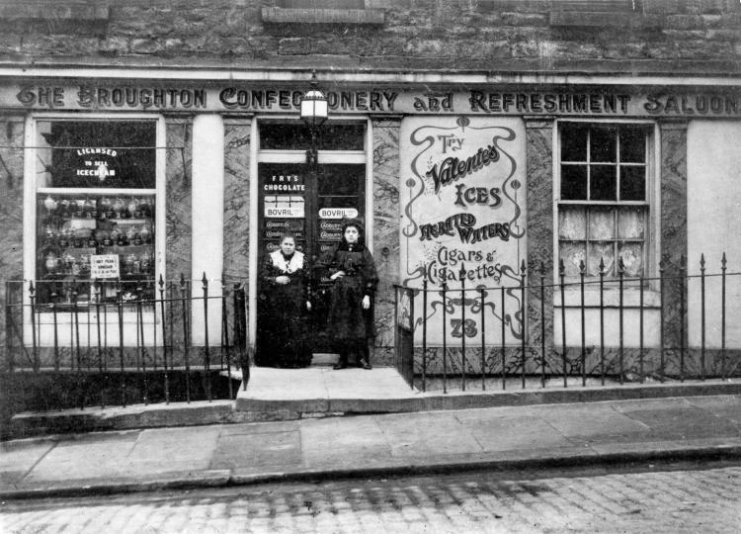
Migration and Empire
1830-1939
Booklet 3
Section 1 – Catholic Irish Immigration
Task 1 – Make a note of the different push and pull factors that led to many Irish people moving to Scotland between 1830 and 1930.

Task 2 – Make a spider diagram to show the problems faced by Catholic Irish immigrants in Scotland.

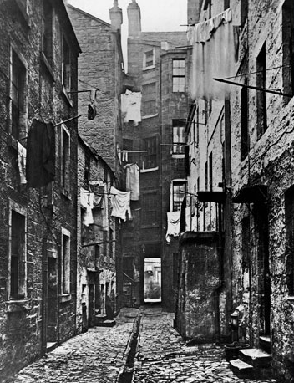

Task 3 – Connect each song to a problem faced by Catholic Irish immigrants in Scotland.
Song | Connection to Irish Problems

Task 3 – Take notes on the relationship between native Scots and the Catholic Irish.
Example 1

Specific Facts | Illustration
Example 2

Specific Facts | Illustration
Example 3

Specific Facts | Illustration
Example 4

Specific Facts | Illustration
Source A is from The Ayr Advertiser, 1849.
The Irish have been driven by the increasing poverty in their own country to emigrate to Scotland. By their hard work railways have been formed and new and important sources of wealth opened up. However, the Irish, during the past ten years, have absolutely inundated this country. They have also swallowed up our rapidly increasing Poor Rates, have directed charity away from its proper channels, and have filled our jails. By their greatest numbers they have lessened wages or totally deprived thousands of the working people of Scotland of that employment which legitimately belonged to them. Lastly, there can be no doubt that their contact with the Scotch has not been for the benefit morally or intellectually of the latter.

Task 4 -Evaluate the usefulness of Source A as evidence of the relations between native Scots and Catholic Irish immigrants. (6)
Origin and Purpose
____________________________________________________________________________________________________________________________________________________________________________________________________________________________________________________________________________________________________________________________________________________________________________________________________________________________________________________________________________________________________________________________________________________________________________________________________________________________________________________________________________________________________________________________________________________________________________________________________________________________________________________________
Source
_______________________________________________________________________________________________________________________________________________________________________________________________________________________________________________________________________________________________________________________________________________________________________________________________________________________________________________________________________________________________________________________________________________________________________________________________________________________________________________________________________________________________________________________________________________________________________________________
Recall_______________________________________________________________________________________________________________________________________________________________________________________________________________________________________________________________________________________________________________________________________________________________________________________________________________________________________________________________________________________________________________________________________________________________________________________________________________________________________________________________________________________________________________________________________________________________________________________________________________________________________________________
Task 5 – To what extent do you think our attitudes as Scots have changed towards immigrants?
_____________________________________________________________________________________________________________________________________________________________________________________________________________________________________________________________________________________________________________________________________________________________________________________________________________________________________________________________________________________________________________________________________________________________________________________________________________________________________________
Task 6 – Find examples of how Catholic Irish assimilated in Scotland, and examples of how they remained separate.
Assimilated | Remained Separate
Section 2 – Protestant Irish Immigration
Task 7 – Investigate the ways in which the experience of Protestant Irish immigrants in Scotland was different to that of Catholic Irish immigrants.
Employment____________________________________________________________________________________________________________________________________________________________________________________________________________________________________________________________________________________________________________________________________________________________________________________________________________________
Relations with Scots ______________________________________________________________________________________________________________________________________________________________________________________________________________________________________________________________________________________________________________________________________________________________________________________________________________________________
Assimilation____________________________________________________________________________________________________________________________________________________________________________________________________________________________________________________________________________________________________________________________________________________________________________________________________________________
Conflict________________________________________________________________________________________________________________________________________________________________________________________________________________________________________________________________________________________________________________________________________________________________________________________________________________________
Source B: from Martin J Mitchell, Irish Catholics in the West of Scotland, in his “New Perspectives on the Irish in Scotland” (2008).
The prevailing view about Catholic Irish in nineteenth-century Scotland is that they were despised by the bulk of the native population, and as a result formed separate and isolated communities in the towns in which they settled in significant numbers. Yet, there is considerable evidence that members of Catholic Irish communities were involved—often in significant numbers—in strikes, trade unions and trade union campaigns. Moreover, this participation was both welcomed and sought by Scottish workers. Some historians have highlighted sectarian riots and disturbances in Scotland in the nineteenth century as proof that there was considerable Protestant working class hostility towards the Catholic Irish community. However, if these incidents are looked at more closely, most of the incidents did not involve Scottish workers, but were instead “Orange” and “Green” disturbances involving Protestant Irish and Catholic Irish immigrants.
Task 8 – How fully does Source B illustrate the experience of Irish immigrants in Scotland? (9)
Source
__________________________________________________________________________________________________________________________________________________________________________________________________________________________________________________________________________________________________________________________________________________________________________________________________________________________________________________________________________________________________________________________________________________________________________________________________________________________________________________________________________________________________________________________________________________________________________________________________________________________________________________________________________________________________________________________________________________________________________________________________________________________________________________________________________________________________________________________________________________________________________________________________________________________________________________________________________________________

Recall
__________________________________________________________________________________________________________________________________________________________________________________________________________________________________________________________________________________________________________________________________________________________________________________________________________________________________________________________________________________________________________________________________________________________________________________________________________________________________________________________________________________________________________________________________________________________________________________________________________________________________________________________________________________________________________________________________________________________________________________________________________________________________________________________________________________________________________________________________________________________________________________________________________________________________________________________________________________________
__________________________________________________________________________________________________________________________________________________________________________________________________________________________________________________________________________________________________________________________________________________________________________________________________________________________________________________________________________________________________________________________________________________________________________________________________________________________________________________________________________________________________________________
Section 3 – Italian Immigrants
Source 1 – ‘Italians settled in Scotland and loved the plaice’ – Herald Scotland 2014
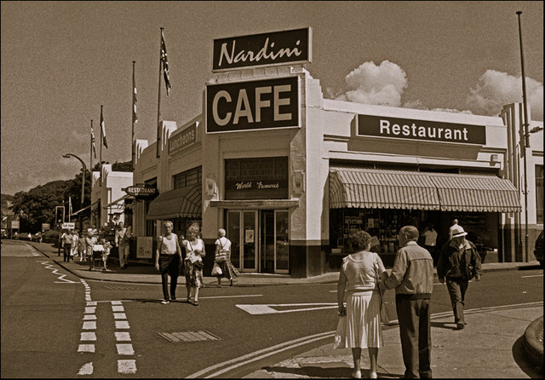
ONE story told about Italians who eschewed poverty in their country and settled in Scotland was of the seven young statue makers from Tuscany, who brought 1000 little figurines of the Virgin Mary to Paisley intent on selling them to make their fortune. Whether Paisley people are less God-fearing than elsewhere, I know not, but the statues did not sell. Disheartened, six of them sold their stock at a knock-down price to the seventh, and returned home. The seventh, a chap called Nardini, refashioned the 1000 Marys as Santa Clauses, and sold the lot - opening a cafe in Largs with the profits.
Other Italian settlers in Scotland had even more chequered lives. Antonio Pacitti arrived in Scotland in the 1890s, and sold ice cream from a cart in Falkirk. He opened a cafe in Camelon, but in a heated argument with a fellow Italian, a cobbler, he accused the man of having an affair with his wife, and shot him. Today it may simply be seen as a crime of passion, but in the Scotland of the early 20th century, Antonio was declared insane, and deported to Italy, where he settled back in Cassino. During the Second World War the Germans ordered him out of his home. He refused, and was shot dead by an SS officer. Antonio's story is told just now on the wall of Hillhead Library, where there is a photographic exhibition of the Pacitti family and its connections with Glasgow.
The rough estimate is that some 20,000 Scots are of Italian heritage. The big growth in Italian immigration was the 1880s to the 1920s, when young men from mainly Barga in Tuscany, and Picinisco in Lazio, left to find work. Although some were skilled stonemasons, or the makers of figurines, they had to take work where they could find it. The previous wave of immigration in Glasgow, the Highlanders, had moved into shipbuilding and other heavy industries. Working long hours they needed cheap and instant nutrition, which is why many Italians saw the opportunity in fish and chip shops, and ice cream parlours.
The Pieri family from Barga ran The Savoy chip shop in Cowcaddens, Glasgow, which then, before the current Herald office civilised the place of course, was a warren of squalid tenements with The Savoy's late night customers often being drunks and ladies of the night. Joe Pieri later wrote the book Tales of the Savoy, in which he recalled they had to employ a "chucker-out" - Big Steve - who kept order. Wrote Joe: "Disturbances would be quickly and efficiently dealt with by Big Steve. If the offender was standing, Steve would approach smilingly, lean over as if to impart a confidence, then stamp the heavy heel of his boot on the man's toes. The ensuing howls of anguish would then stop suddenly to be replaced by gasping, gargling, noises as a sharp blow was delivered to the solar plexus, after which the culprit, now reduced to an ineffective mass of jelly, would be deposited none too gently on the pavement." Yes, happy days.
These connections still exist. When Italian rock legend Zucchero, less well known here, was appearing at the SECC a few years back, the Scottish Italian community was out in force. An older Italian-looking couple arrived, and as they took their seats, the gentleman surveyed the audience and exclaimed: "Jeez oh. How's anyboady in Glesga gonnae get a fish supper the night?"
The temperance movement supported the Italian cafes as it kept folk out of the pubs. Others, though, saw them as dens of iniquity, especially if they opened on a Sunday, tempting young people to meet members of the opposite sex and indulge in smoking, and even dancing.
Writer Sergio Casci says the sense of identity in the Scottish Italian community is still very strong, although the community itself is not as close-knit. "One of the differences," says Sergio, "between Scottish Italians and those who settled in America and Australia is that it was easier for those in Scotland to keep in touch with their roots, as it was only one or two days travel to go back to Italy. Folk often went back to meet wives or husbands or to go on holiday. "The Scots and the Italians got on pretty well. Going to get fish and chips or ice cream tended to be a positive thing and made the Italians popular. They were often happy, friendly, outgoing people, which the Scots liked." Fish and chips, though, was not brought over from Italy with the Italian immigrants. It was unheard of in the land of the Mediterranean diet. But now so many former Italian fish fryers have retired to their native village of Barga, that they now have an annual fish and chip festival, frying the stuff up in big vats on the local football pitch. It's good to give something back - just a shame it's coronary artery disease.
Task 9 – What did Italians do to make a living in Scotland?
______________________________________________________________________________________________________________________________________________________________________________________________________________________________________________________________________________________________________________________________________________________________________________________________________________________________________________________________________________________________________________________________________________________________________________________________________________________________________________________________________________________________________________________________________________________________________________________________________________________________________________________________________________________________________________________________________________________________________________________________________
Task 10 – Did Scots and Italians get on well? Find at least 3 examples for both sides before coming to an overall conclusion.
Yes | No
Conclusion

___________________________________________________________________________________________________________________________________________________________________________________________________________________________________________________________________________________________________________________________________________________________________________________________________________________________________________________________________________________________________
Source C: adapted from New Arrivals by Tony Jaconelli in Our Glasgow Story.
On New Year’s day 1921, I trailed along holding on to my younger brother, Michael. Our father, Domenico, carried Biagio. My oldest brother, Giacomo, brought up the rear. We had left our warm village in Italy to join Domenico’s brother in some place called Scotland. School was a nightmare for me but Giacomo, a name that was quickly shortened to Jack, revelled in school life. He was a quick learner and always able to take care of himself. A few times I found myself surrounded by classmates chanting at me because I was a foreigner. Jack scattered them and they stopped bothering me completely. Our family moved house a few times in an effort to improve our lot. Domenico took a job in the largely Italian trade of terrazzo tile workers and most of my brothers followed him into the trade. Meanwhile my grasp of the Glasgow dialect improved daily. Within a couple of years I lost all trace of my mother tongue and developed a strong, guttural Glasgow accent. In no time at all I was a complete Glaswegian and able to befriend Scottish boys and girls.
Task 11 – Evaluate the usefulness of Source C as evidence of relations between Scots and Italians. (6)

Origin and Purpose
______________________________________________________________________________________________________________________________________________________________________________________________________________________________________________________________________________________________________________________________________________________________________________________________________________________________________________________________________________________________________________________________________________________________________________________________________________________________________________________________________________________________________________________________________________________________________________________________________________________________________________________________________________________________________________________________________________________________________________________________________
Source
_________________________________________________________________________________________________________________________________________________________________________________________________________________________________________________________________________________________________________________________________________________________________________________________________________________________________________________________________________________________________________________________________________________________________________________________________________________________________________________________________________________________________________________________________________________________________________________________________________________________________________________________________________________________________________________________________
Recall
_________________________________________________________________________________________________________________________________________________________________________________________________________________________________________________________________________________________________________________________________________________________________________________________________________________________________________________________________________________________________________________________________________________________________________________________________________________________________________________________________________________________________________________________________________________________________________________________________________________________________________________________________________________________________________________________________
Task 12 – To what extent did Italians assimilate into Scottish life?
Became more Scottish | Remained Separate
Conclusion

___________________________________________________________________________________________________________________________________________________________________________________________________________________________________________________________________________________________________________________________________________________________________________________________________________________________________________________________________________________________________
Source D was written by the historian Tom Devine in his book ‘The Scottish Nation 1700-2000’

‘Italian was spoken at home, food was in the Italian style, and children were expected to marry Italians. The social life of the girls of the family was especially restricted. Most time was spent in the shops because of the long working hours and the room behind the shop counter became the meeting points for friends and relatives. For many the hope, and for some the reality was eventually to return to Italy.’

Task 13 – How fully does Source D describe the assimilation of Italians in Scotland? (7)

Source
_______________________________________________________________________________________________________________________________________________________________________________________________________________________________________________________________________________________________________________________________________________________________________________________________________________________________________________________________________________________________________________________________________________________________________________________________________________________________________________________________________________________________________________________________________________________________________________________________________________________________________________________________________________________________________________________________________________________________________________________________________________________________________________________________________________________________________________________________________________________________________________________________________________________________________________________________________________________________________________________________________________________________

Recall_____________________________________________________________________________________________________________________________________________________________________________________________________________________________________________________________________________________________________________________________________________________________________________________________________________________________________________________________________________________________________________________________________________________________________________________________________________________________________________________________________________________________________________________________________________________________________________________________________________________________________________________________________________________________________________________________________________________________________________________________________________________________________________________________________________________________________________________________________________________________________________________________________________________________________________________________________________________
Task 14 – Connect each song to Italian immigration to Scotland.
Song | Connection to Italian Immigration
Section 4 – Jewish Immigrants
Source 2 – from Scotland’s Jews, 2008
Much of the early economic activity of members of the Jewish communities in Scotland was based on production and merchandising of goods. New Jewish entrepreneurs set up businesses manufacturing a wide range of clothing, including the cloth cap. Most of the working members of Scottish Jewry were heavily concentrated in just a few trades and industries, such as shopkeeping, tailoring, shoe and slipper making, and the manufacture and distribution of furniture and picture frames. In the years before the First World War, many Jews began their businesses peddling to mining communities.
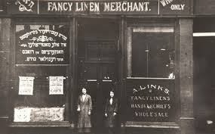
However, despite the success of some individuals, much of the Jewish community, especially those in the Gorbals in Glasgow, remained trapped in poverty. Despite financial difficulties, increasing numbers of Jews entered the universities of Glasgow and Edinburgh, especially in the years after the First World War. Higher education was for many the means of escape from the old ghetto trades. Medicine was the most popular career choice, offering status and income. Many Jews also went into teaching, but law was less popular as it was hard for Jews to break into the conservative Scottish legal profession. A considerable number of foreign Jewish medical students studied medicine in Scotland in the 1920s and 1930s. Many Jewish Americans came to Glasgow, Edinburgh, Dundee and St. Andrews, having been denied medical school places in the United States because of discrimination.
Task 15 - What did Jews do to make a living in Scotland?
__________________________________________________________________________________________________________________________________________________________________________________________________________________________________________________________________________________________________________________________________________________________________________________________________________________________________________________________________________________________________________________________________________________________________________________________________________________________________________________________________________________________________________________
Task 16 – Did Jews and Scots get on well?
Yes | No
Conclusion

___________________________________________________________________________________________________________________________________________________________________________________________________________________________________________________________________________________________________________________________________________________________________________________________________________________________________________________________________________________________________

Task 17 – How useful is Source B as evidence of relations between native Scots and immigrants? 6
Source B: from the Scottish Jewish Archives Centre. Testimony given by Alec Bernstein, a first-generation Scot born to an immigrant family.
I was born in Ayr on 24th June 1911 and in Ayr at that time there were about nine Jewish families in all. My father’s full name was Philip Bernstein; he came from Skood in Russia. My mother came from Weidz in Russia near Vilna. They must have come here at the turn of the century. When I went to school I was the only Jewish kid in class, in fact I was the only Jewish kid in the school. And at that time, during the Great War, I was knocked around a lot. The kids used to crowd around me, pinch my lunch from me and shout “You German Jew, you German Jew” (even though I was of Russian descent). As a result my life was miserable there. It made me a very timid child. My full name is Isaac. When I was 14, I went to work in a warehouse and the Jewish manager there said “That’s some name you’ve got. We’ll call you Alec from now on”. So since I was 14 I’ve been called Alec.

Origin and Purpose
______________________________________________________________________________________________________________________________________________________________________________________________________________________________________________________________________________________________________________________________________________________________________________________________________________________________________________________________________________________________________________________________________________________________________________________________________________________________________________________________________________________________________________________________________________________________________________________________________________________________________________________________________________________________________________________________________________________________________________________________________

Source
_________________________________________________________________________________________________________________________________________________________________________________________________________________________________________________________________________________________________________________________________________________________________________________________________________________________________________________________________________________________________________________________________________________________________________________________________________________________________________________________________________________________________________________________________________________________________________________________________________________________________________________________________________________________________________________________________
Recall
_________________________________________________________________________________________________________________________________________________________________________________________________________________________________________________________________________________________________________________________________________________________________________________________________________________________________________________________________________________________________________________________________________________________________________________________________________________________________________________________________________________________________________________________________________________________________________________________________________________________________________________________________________________________________________________________________
Task 18 – To what extent did Jews assimilate into Scottish life?
Became more Scottish | Remained Separate
Conclusion

___________________________________________________________________________________________________________________________________________________________________________________________________________________________________________________________________________________________________________________________________________________________________________________________________________________________________________________________________________________________________
Section 5 – Lithuanian Immigrants
Task 19 – Take notes under the 3 headings below.
Employment

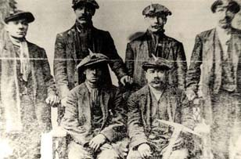
Relationship with Scots

Assimilation

